Accessibility Conformance Report for ReCollect’s ReCollect Web Widgets 2025

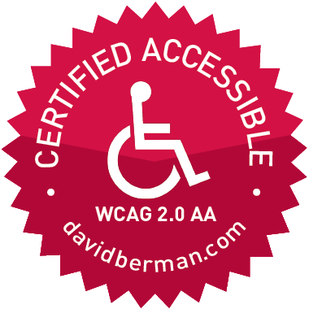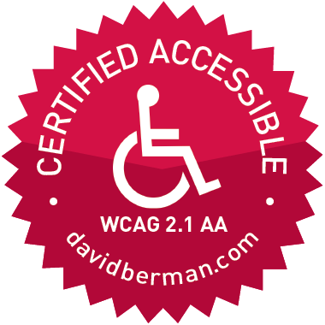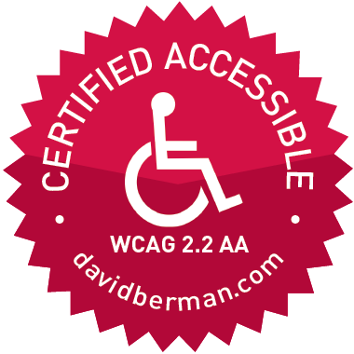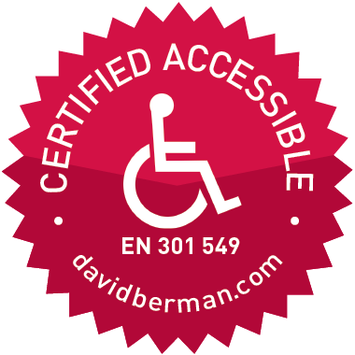
David Berman, CPWA, ADS, WAS, CPACC
David Berman Communications | www.davidberman.com | www.wcag2.com
berman@davidberman.com | @davidberman
+1-613-728-6777 | 340 Selby Avenue, Ottawa, Canada K2A 3X6
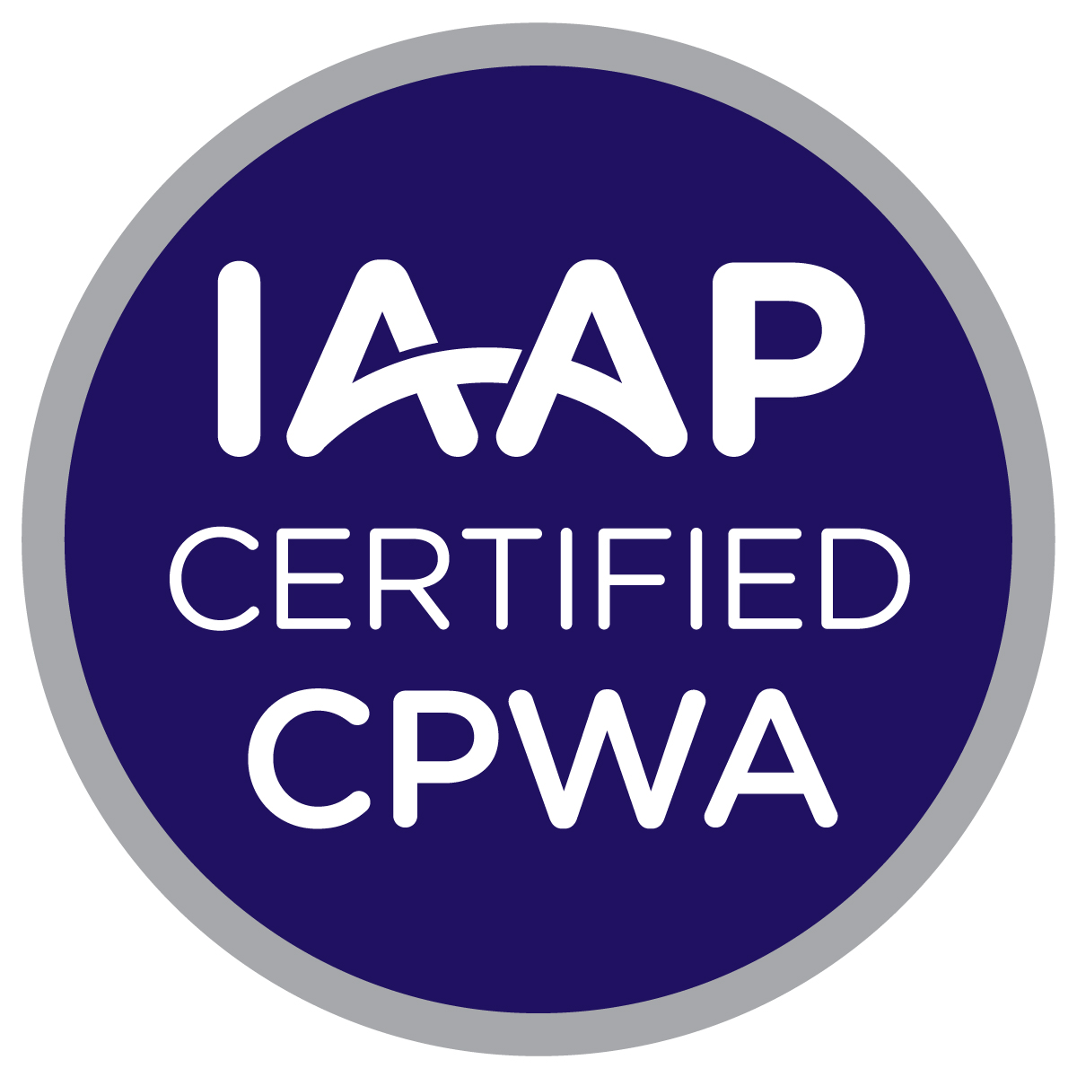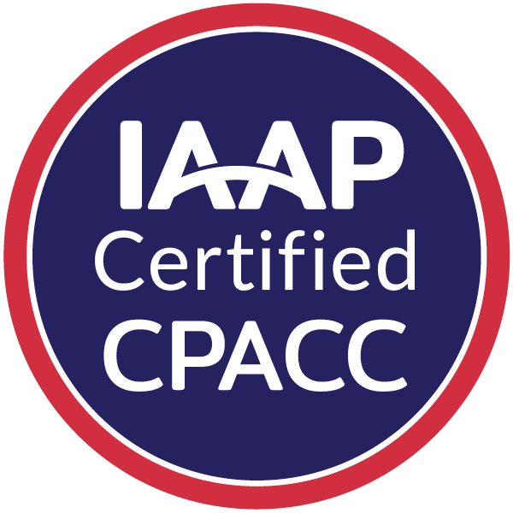
“When we design for the extremes, everyone benefits.”

Accessibility Conformance Report
for ReCollect’s ReCollect Web Widgets 2025

International Edition
(Based on latest VPAT® Version 2.5 International Edition template, published November 2023)
by David Berman Communications
This document conforms with all applicable EN 301 549, WCAG 2.0, WCAG 2.1, and WCAG 2.2 Level A and Level AA guidelines for accessible digital documents. For alternative formats, please contact David Berman Communications at info@davidberman.com or 1-613-728-6777.
“Voluntary Product Accessibility Template” and “VPAT” are registered service marks of the Information Technology Industry Council (ITI)
Name of Product/Version:
ReCollect Web Widgets 2025 (in English, French, Chinese, Hindi, Korean, Spanish, Vietnamese, Punjabi)

Report Date:
31 July 2026
Product Description:
Web browser-based waste collection and waste diversion tabbed widgets, for residents, for inclusion within municipal websites, with declared support by the client for these platform combinations:
- Apple Safari (current version) on macOS, with and without VoiceOver
- Google Chrome (current version) on Windows 10 and 11 (with and without both NVDA and JAWS) and macOS (VoiceOver)
- Microsoft Edge (current version) on Windows 10 and 11, with and without both NVDA and JAWS)
- Mozilla Firefox (current version) on Windows (with and without NVDA and JAWS)
Adobe Reader (as applicable, various platforms)
Contact Information:
David Berman | +1-613-728-6777 | berman@davidberman.com | www.davidberman.com/about

Notes:

All in-scope aspects of the product conform to:
- WCAG 2.2 Level A and AA (as designated by the EU’s anticipated EN 301 549 (2026) and by the UK’s PSBAR), and
- WCAG 2.1 Level A and AA (as designated by ADA Title II Final Rule (2024), ACA Phase 1 regulations, EN 301 549 (2021), Canada’s ICT Standard CAN/ASC EN 301 549, Australia’s AS EN 301 549, and AMA), and
- WCAG 2.0 Level A and AA (as designated by U.S. Section 508 and Ontario’s AODA Section 14), and

- all current and past versions of EN 301 549 (including Australia’s AS EN 301 549 and Canada’s ICT Standard CAN/ASC EN 301 549), as well as the EU’s anticipated EN 301 549 (2026)
Following the W3C’s WCAG-EM evaluation methodology, we evaluated the product to the extent access was provided to us by the client.
We worked extensively with ReCollect on remediation, coaching, and cyclical reauditing prior to authoring this ACR (VPAT) for the Recollect Web widgets product. Their enthusiasm and dedication to making their product accessible is authentic: we identified several issues where they chose to go beyond the minimum in the techniques that they chose to embrace in our discussions together, and I am confident that they intend to continue that pattern with us for future releases.
Designations of “Supports” are based upon the deeper commentary on each matter documented within the Accessibility Remediation Report (ARR) document that we developed and shared directly with the development team as their agenda for working through any conformance issues, which they may share with you upon request. Each of those issues were successfully and satisfactorily remediated by their team and re-evaluated by our team as part of the journey that led to this report.

Evaluation Methods Used:
Testing (and all tools used in our analysis) followed W3C’s WCAG-EM evaluation methodology.

Tools:
Auditing is accomplished using the following tools (and methods):
Automated testing tools for browsers: WebAim WAVE, Deque axe
Manual testing tools we use, with and without assistive technology, as needed and if in scope:
- A variety of keyboards, pointing devices, and/or switches
- Screen readers (JAWS, Narrator, NVDA, VoiceOver)
- Colour Contrast Analyser
- JAWS Inspect
- PEAT
- Screen magnifiers (see Functional Methods below)
- Zimmerman Low Vision Simulation Kit
- ZoomText
Functional Methods: The audit included comprehensive human (manual) review of each success criterion, including (but not limited to) these functional methods:
- using the keyboard only (or keyboard-only equivalents)
- muting sound controls
- screen magnification (using each operating system’s control set, using the user agent’s overall zoom function, using the user agent’s “zoom text only” functionality)
- navigation following top tasks as per discussion with client, as well as the overall framework
- examination of:
  - typeface treatments, sizing, and horizontal and vertical spacing
  - hue usage and contrast (with and without high contrast display)
  - content layouts, flow, and structure
  - semantic layout and structure
  - predictability
  - content flow and navigability via non-keyboard input
  - interactive patterns for comprehension and readability
  - error situations and recovery
  - responsive design scenarios (at each breakpoint)
  - built-in accessibility features of each targeted operating system
  - application of the principles of Universal Design for Learning
  - observations via spot testing by users with lived experience
Our testing is conducted by a diverse group of testers with and without disabilities. Furthermore, at least three accessibility experts work on every audit, including peer review and certification steps involving fully certified professionals with the top digital accessibility certifications available worldwide (US Government DHS Trusted Tester and all IAAP digital accessibility certifications, including CPWA, WAS, and ADS certifications).
Accessibility Test Coordinator:
David Berman, cpwa ads

Web Accessibility Testers Team Leads:
Ben Armitage dhs tt, David Berman cpwa, was, Michael Cooper, was

Applicable Standards/Guidelines
This report covers the degree of conformance for the following accessibility standard/guidelines:
Standard/Guideline | Included in Report
Web Content Accessibility Guidelines 2.0 | Level A: Yes  Level AA: Yes  Level AAA: No
Web Content Accessibility Guidelines 2.1 | Level A: Yes  Level AA: Yes  Level AAA: No
Web Content Accessibility Guidelines 2.2 | Level A: Yes  Level AA: Yes  Level AAA: No
Revised Section 508 standards published January 18, 2017 and corrected January 22, 2018 | Yes
EN 301 549 Accessibility requirements for ICT products and services - V3.1.1 (2019-11) AND EN 301 549 Accessibility requirements for ICT products and services - V3.2.1 (2021-03) | Yes

Terms
The terms used in the Conformance Level information are defined as follows:
- Supports: The functionality of the product has at least one method that meets the criterion without known defects or meets with equivalent facilitation.
- Partially Supports (equivalent to “Supports with Exceptions” in VPAT 2.4 and earlier): Some functionality of the product does not meet the criterion.
- Does Not Support: The majority of product functionality does not meet the criterion.
- Not Applicable: The criterion is not relevant to the product.
- Not Evaluated: The product has not been evaluated against the criterion. This can be only be used in WCAG Level AAA criteria.

WCAG 2.x Report
Tables 1 and 2 also document conformance with:
- EN 301 549: Chapter 9 - Web, Sections 10.1-10.4 of Chapter 10 - Non-Web documents, and Sections 11.1-11.4 and 11.8.2 of Chapter 11 - Non-Web Software (open and closed functionality), and Sections 12.1.2 and 12.2.4 of Chapter 12 – Documentation
- Revised Section 508: Chapter 5 – 501.1 Scope, 504.2 Content Creation or Editing, and Chapter 6 – 602.3 Electronic Support Documentation.
Note: When reporting on conformance with the WCAG 2.x Success Criteria, they are scoped for full pages, complete processes, and accessibility-supported ways of using technology as documented in the WCAG 2.0 Conformance Requirements.

Table 1: Success Criteria, Level A
Notes: None
 | Criteria | Conformance Level | Remarks and Explanations
1.1.1 Non-text Content (Level A)  Also applies to:  EN 301 549 Criteria  - 9.1.1.1 (Web)  - 10.1.1.1 (Non-Web Document)  - 11.1.1.1.1 (Open Functionality Software)  - 11.1.1.1.2 (Closed Functionality Software)  - 11.8.2 (Authoring Tool)  - 12.1.2 (Product Docs)  - 12.2.4 (Support Docs)  Revised Section 508  - 501 (Web)(Software)  - 504.2 (Authoring Tool)  - 602.3 (Support Docs) |  | Supports | None
1.2.1 Audio-only and Video-only (Prerecorded) (Level A)  Also applies to:  EN 301 549 Criteria  - 9.1.2.1 (Web)  - 10.1.2.1 (Non-Web Document)  - 11.1.2.1.1 (Open Functionality Software)  - 11.1.2.1.2.1 and 11.1.2.1.2.2 (Closed Software)  - 11.8.2 (Authoring Tool)  - 12.1.2 (Product Docs)  - 12.2.4 (Support Docs)  Revised Section 508  - 501 (Web)(Software)  - 504.2 (Authoring Tool)  - 602.3 (Support Docs) |  | Supports | This product does not contain any multimedia.
1.2.2 Captions (Prerecorded) (Level A)  Also applies to:  EN 301 549 Criteria  - 9.1.2.2 (Web)  - 10.1.2.2 (Non-Web Document)  - 11.1.2.2 (Open Functionality Software)  - 11.1.2.2 (Closed Software)  - 11.8.2 (Authoring Tool)  - 12.1.2 (Product Docs)  - 12.2.4 (Support Docs)  Revised Section 508  - 501 (Web)(Software)  - 504.2 (Authoring Tool)  - 602.3 (Support Docs) |  | Supports | None
1.2.3 Audio Description or Media Alternative (Prerecorded) (Level A)  Also applies to:  EN 301 549 Criteria  - 9.1.2.3 (Web)  - 10.1.2.3 (Non-Web Document)  - 11.1.2.3.1 (Open Functionality Software)  - 11.1.2.3.2 (Closed Software)  - 11.8.2 (Authoring Tool)  - 12.1.2 (Product Docs)  - 12.2.4 (Support Docs)  Revised Section 508  - 501 (Web)(Software)  - 504.2 (Authoring Tool)  - 602.3 (Support Docs) |  | Supports | This product does not contain any multimedia.
1.3.1 Info and Relationships (Level A)  Also applies to:  EN 301 549 Criteria  - 9.1.3.1 (Web)  - 10.1.3.1 (Non-Web Document)  - 11.1.3.1.1 (Open Functionality Software)  - 11.1.3.1.2 (Closed Software)  - 11.8.2 (Authoring Tool)  - 12.1.2 (Product Docs)  - 12.2.4 (Support Docs)  Revised Section 508  - 501 (Web)(Software)  - 504.2 (Authoring Tool)  - 602.3 (Support Docs) |  | Supports | None
1.3.2 Meaningful Sequence (Level A)  Also applies to:  EN 301 549 Criteria  - 9.1.3.2 (Web)  - 10.1.3.2 (Non-Web Document)  - 11.1.3.2.1 (Open Functionality Software)  - 11.1.3.2.2 (Closed Software)  - 11.8.2 (Authoring Tool)  - 12.1.2 (Product Docs)  - 12.2.4 (Support Docs)  Revised Section 508  - 501 (Web)(Software)  - 504.2 (Authoring Tool)  - 602.3 (Support Docs) |  | Supports | None
1.3.3 Sensory Characteristics (Level A)  Also applies to:  EN 301 549 Criteria  - 9.1.3.3 (Web)  - 10.1.3.3 (Non-Web Document)  - 11.1.3.3 (Open Functionality Software)  - 11.1.3.3 (Closed Software)  - 11.8.2 (Authoring Tool)  - 12.1.2 (Product Docs)  - 12.2.4 (Support Docs)  Revised Section 508  - 501 (Web)(Software)  - 504.2 (Authoring Tool)  - 602.3 (Support Docs) |  | Supports | None
1.4.1 Use of Color (Level A)  Also applies to:  EN 301 549 Criteria  - 9.1.4.1 (Web)  - 10.1.4.1 (Non-Web Document)  - 11.1.4.1 (Open Functionality Software)  - 11.1.4.1 (Closed Software)  - 11.8.2 (Authoring Tool)  - 12.1.2 (Product Docs)  - 12.2.4 (Support Docs)  Revised Section 508  - 501 (Web)(Software)  - 504.2 (Authoring Tool)  - 602.3 (Support Docs) |  | Supports | None
1.4.2 Audio Control (Level A)  Also applies to:  EN 301 549 Criteria  - 9.1.4.2 (Web)  - 10.1.4.2 (Non-Web Document)  - 11.1.4.2 (Open Functionality Software)  - 11.1.4.2 (Closed Software)  - 11.8.2 (Authoring Tool)  - 12.1.2 (Product Docs)  - 12.2.4 (Support Docs)  Revised Section 508  - 501 (Web)(Software)  - 504.2 (Authoring Tool)  - 602.3 (Support Docs) |  | Supports | This product does not contain any multimedia.
2.1.1 Keyboard (Level A)  Also applies to:  EN 301 549 Criteria  - 9.2.1.1 (Web)  - 10.2.1.1 (Non-Web Document)  - 11.2.1.1.1 (Open Functionality Software)  - 11.2.1.1.2 (Closed Software)  - 11.8.2 (Authoring Tool)  - 12.1.2 (Product Docs)  - 12.2.4 (Support Docs)  Revised Section 508  - 501 (Web)(Software)  - 504.2 (Authoring Tool)  - 602.3 (Support Docs) |  | Supports | None
2.1.2 No Keyboard Trap (Level A)  Also applies to:  EN 301 549 Criteria  - 9.2.1.2 (Web)  - 10.2.1.2 (Non-Web Document)  - 11.2.1.2 (Open Functionality Software)  - 11.2.1.2 (Closed Software)  - 11.8.2 (Authoring Tool)  - 12.1.2 (Product Docs)  - 12.2.4 (Support Docs)  Revised Section 508  - 501 (Web)(Software)  - 504.2 (Authoring Tool)  - 602.3 (Support Docs) |  | Supports | None
2.1.4 Character Key Shortcuts (Level A 2.1 and 2.2)  Also applies to:  EN 301 549 Criteria  - 9.2.1.4 (Web)  - 10.2.1.4 (Non-Web Document)  - 11.2.1.4.1 (Open Functionality Software)  - 11.2.1.4.2 (Closed Software)  - 11.8.2 (Authoring Tool)  - 12.1.2 (Product Docs)  - 12.2.4 (Support Docs)  Revised Section 508 – Does not apply |  | Supports | None
2.2.1 Timing Adjustable (Level A)  Also applies to:  EN 301 549 Criteria  - 9.2.2.1 (Web)  - 10.2.2.1 (Non-Web Document)  - 11.2.2.1 (Open Functionality Software)  - 11.2.2.1 (Closed Software)  - 11.8.2 (Authoring Tool)  - 12.1.2 (Product Docs)  - 12.2.4 (Support Docs)  Revised Section 508  - 501 (Web)(Software)  - 504.2 (Authoring Tool)  - 602.3 (Support Docs) |  | Supports | None
2.2.2 Pause, Stop, Hide (Level A)  Also applies to:  EN 301 549 Criteria  - 9.2.2.2 (Web)  - 10.2.2.2 (Non-Web Document)  - 11.2.2.2 (Open Functionality Software)  - 11.2.2.2 (Closed Software)  - 11.8.2 (Authoring Tool)  - 12.1.2 (Product Docs)  - 12.2.4 (Support Docs)  Revised Section 508  - 501 (Web)(Software)  - 504.2 (Authoring Tool)  - 602.3 (Support Docs) |  | Supports | None
2.3.1 Three Flashes or Below Threshold (Level A)  Also applies to:  EN 301 549 Criteria  - 9.2.3.1 (Web)  - 10.2.3.1 (Non-Web Document)  - 11.2.3.1 (Open Functionality Software)  - 11.2.3.1(Closed Software)  - 11.8.2 (Authoring Tool)  - 12.1.2 (Product Docs)  - 12.2.4 (Support Docs)  Revised Section 508  - 501 (Web)(Software)  - 504.2 (Authoring Tool)  - 602.3 (Support Docs) |  | Supports | None
2.4.1 Bypass Blocks (Level A)  Also applies to:  EN 301 549 Criteria  - 9.2.4.1 (Web)  - 10.2.4.1 (Non-Web Document) – Does not apply  - 11.2.4.1 (Open Functionality Software) – Does not apply  - 11.2.4.1 (Closed Software) – Does not apply  - 11.8.2 (Authoring Tool)  - 12.1.2 (Product Docs)  - 12.2.4 (Support Docs)  Revised Section 508  - 501 (Web)(Software) – Does not apply to non-web software  - 504.2 (Authoring Tool)  - 602.3 (Support Docs) – Does not apply to non-web docs |  | Supports | None
2.4.2 Page Titled (Level A)  Also applies to:  EN 301 549 Criteria  - 9.2.4.2 (Web)  - 10.2.4.2 (Non-Web Document)  - 11.2.4.2 (Open Functionality Software) - Does not apply  - 11.2.4.2 (Closed Software) – Does not apply  - 11.8.2 (Authoring Tool)  - 12.1.2 (Product Docs)  - 12.2.4 (Support Docs)  Revised Section 508  - 501 (Web)(Software)  - 504.2 (Authoring Tool)  - 602.3 (Support Docs) |  | Supports | None
2.4.3 Focus Order (Level A)  Also applies to:  EN 301 549 Criteria  - 9.2.4.3 (Web)  - 10.2.4.3 (Non-Web Document)  - 11.2.4.3 (Open Functionality Software)  - 11.2.4.3 (Closed Software)  - 11.8.2 (Authoring Tool)  - 12.1.2 (Product Docs)  - 12.2.4 (Support Docs)  Revised Section 508  - 501 (Web)(Software)  - 504.2 (Authoring Tool)  - 602.3 (Support Docs) |  | Supports | None
2.4.4 Link Purpose (In Context) (Level A)  Also applies to:  EN 301 549 Criteria  - 9.2.4.4 (Web)  - 10.2.4.4 (Non-Web Document)  - 11.2.4.4 (Open Functionality Software)  - 11.2.4.4 (Closed Software  - 11.8.2 (Authoring Tool)  - 12.1.2 (Product Docs)  - 12.2.4 (Support Docs)  Revised Section 508  - 501 (Web)(Software)  - 504.2 (Authoring Tool)  - 602.3 (Support Docs) |  | Supports | None
2.5.1 Pointer Gestures (Level A 2.1 and 2.2)  Also applies to:  EN 301 549 Criteria  - 9.2.5.1 (Web)  - 10.2.5.1 (Non-Web Document)  - 11.2.5.1 (Open Functionality Software)  - 11.2.5.1 (Closed Software)  - 11.8.2 (Authoring Tool)  - 12.1.2 (Product Docs)  - 12.2.4 (Support Docs)  Revised Section 508 – Does not apply |  | Supports | None
2.5.2 Pointer Cancellation (Level A 2.1 and 2.2)  Also applies to:  EN 301 549 Criteria  - 9.2.5.2 (Web)  - 10.2.5.2 (Non-Web Document)  - 11.2.5.2 (Open Functionality Software)  - 11.2.5.2 (Closed Software)  - 11.8.2 (Authoring Tool)  - 12.1.2 (Product Docs)  - 12.2.4 (Support Docs)  Revised Section 508 – Does not apply |  | Supports | None
2.5.3 Label in Name (Level A 2.1 and 2.2)  Also applies to:  EN 301 549 Criteria  - 9.2.5.3 (Web)  - 10.2.5.3 (Non-Web Document)  - 11.2.5.3 (Open Functionality Software)  - 11.2.5.3 (Closed Software)  - 11.8.2 (Authoring Tool)  - 12.1.2 (Product Docs)  - 12.2.4 (Support Docs)  Revised Section 508 – Does not apply |  | Supports | None
2.5.4 Motion Actuation (Level A 2.1 and 2.2)  Also applies to:  EN 301 549 Criteria  - 9.2.5.4 (Web)  - 10.2.5.4 (Non-Web Document)  - 11.2.5.4 (Open Functionality Software)  - 11.2.5.4 (Closed Software  - 11.8.2 (Authoring Tool)  - 12.1.2 (Product Docs)  - 12.2.4 (Support Docs)  Revised Section 508 – Does not apply |  | Supports | None
3.1.1 Language of Page (Level A)  Also applies to:  EN 301 549 Criteria  - 9.3.1.1 (Web)  - 10.3.1.1 (Non-Web Document)  - 11.3.1.1.1 (Open Functionality Software)  - 11.3.1.1.2 (Closed Software)  - 11.8.2 (Authoring Tool)  - 12.1.2 (Product Docs)  - 12.2.4 (Support Docs)  Revised Section 508  - 501 (Web)(Software)  - 504.2 (Authoring Tool)  - 602.3 (Support Docs) |  | Supports | None
3.2.1 On Focus (Level A)  Also applies to:  EN 301 549 Criteria  - 9.3.2.1 (Web)  - 10.3.2.1 (Non-Web Document)  - 11.3.2.1 (Open Functionality Software)  - 11.3.2.1 (Closed Software)  - 11.8.2 (Authoring Tool)  - 12.1.2 (Product Docs)  - 12.2.4 (Support Docs)  Revised Section 508  - 501 (Web)(Software)  - 504.2 (Authoring Tool)  - 602.3 (Support Docs) |  | Supports | None
3.2.2 On Input (Level A)  Also applies to:  EN 301 549 Criteria  - 9.3.2.2 (Web)  - 10.3.2.2 (Non-Web Document)  - 11.3.2.2 (Open Functionality Software)  - 11.3.2.2 (Closed Software)  - 11.8.2 (Authoring Tool)  - 12.1.2 (Product Docs)  - 12.2.4 (Support Docs)  Revised Section 508  - 501 (Web)(Software)  - 504.2 (Authoring Tool)  - 602.3 (Support Docs) |  | Supports | None
3.2.6 Consistent Help (Level A 2.2 only)  EN 301 549 Criteria – Does not apply  Revised Section 508 – Does not apply |  | Supports | None
3.3.1 Error Identification (Level A)  Also applies to:  EN 301 549 Criteria  - 9.3.3.1 (Web)  - 10.3.3.1 (Non-Web Document)  - 11.3.3.1.1 (Open Functionality Software)  - 11.3.3.1.2 (Closed Software)  - 11.8.2 (Authoring Tool)  - 12.1.2 (Product Docs)  - 12.2.4 (Support Docs)  Revised Section 508  - 501 (Web)(Software)  - 504.2 (Authoring Tool)  - 602.3 (Support Docs) |  | Supports | None
3.3.2 Labels or Instructions (Level A)  Also applies to:  EN 301 549 Criteria  - 9.3.3.2 (Web)  - 10.3.3.2 (Non-Web Document)  - 11.3.3.2 (Open Functionality Software)  - 11.3.3.2 (Closed Software)  - 11.8.2 (Authoring Tool)  - 12.1.2 (Product Docs)  - 12.2.4 (Support Docs)  Revised Section 508  - 501 (Web)(Software)  - 504.2 (Authoring Tool)  - 602.3 (Support Docs) |  | Supports | None
3.3.7 Redundant Entry (Level A 2.2 only)  EN 301 549 Criteria – Does not apply  Revised Section 508 – Does not apply |  | Supports | None
4.1.1 Parsing (Level A)  Applies to:  WCAG 2.0 and 2.1 – Always answer ‘Supports’  WCAG 2.2 (obsolete and removed) - Does not apply  EN 301 549 Criteria  - 9.4.1.1 (Web)  - 10.4.1.1 (Non-Web Document)  - 11.4.1.1.1 (Open Functionality Software)  - 11.4.1.1.2 (Closed Software) – Does not apply  - 11.8.2 (Authoring Tool)  - 12.1.2 (Product Docs)  - 12.2.4 (Support Docs)  Revised Section 508  - 501 (Web)(Software)  - 504.2 (Authoring Tool)  - 602.3 (Support Docs) |  | Supports | For WCAG 2.0, 2.1, EN 301 549, and Revised 508 Standards, the September 2023 errata update indicates this criterion is always supported. See the WCAG 2.0 Editorial Errata and the WCAG 2.1 Editorial Errata.
4.1.2 Name, Role, Value (Level A)  Also applies to:  EN 301 549 Criteria  - 9.4.1.2 (Web)  - 10.4.1.2 (Non-Web Document)  - 11.4.1.2.1 (Open Functionality Software)  - 11.4.1.2.2 (Closed Software) – Does not apply  - 11.8.2 (Authoring Tool)  - 12.1.2 (Product Docs)  - 12.2.4 (Support Docs)  Revised Section 508  - 501 (Web)(Software)  - 504.2 (Authoring Tool)  - 602.3 (Support Docs) |  | Supports | None

Table 2: Success Criteria, Level AA
Notes: None
 | Criteria | Conformance Level | Remarks and Explanations
1.2.4 Captions (Live) (Level AA)  Also applies to:  EN 301 549 Criteria  - 9.1.2.4 (Web)  - 10.1.2.4 (Non-Web Document)  - 11.1.2.4 (Open Functionality Software)  - 11.1.2.4 (Closed Software)  - 11.8.2 (Authoring Tool)  - 12.1.2 (Product Docs)  - 12.2.4 (Support Docs)  Revised Section 508  - 501 (Web)(Software)  - 504.2 (Authoring Tool)  - 602.3 (Support Docs) |  | Supports | This product does not contain any live multimedia.
1.2.5 Audio Description (Prerecorded) (Level AA)  Also applies to:  EN 301 549 Criteria  - 9.1.2.5 (Web)  - 10.1.2.5 (Non-Web Document)  - 11.1.2.5 (Open Functionality Software)  - 11.1.2.5 (Closed Software)  - 11.8.2 (Authoring Tool)  - 12.1.2 (Product Docs)  - 12.2.4 (Support Docs)  Revised Section 508  - 501 (Web)(Software)  - 504.2 (Authoring Tool)  - 602.3 (Support Docs) |  | Supports | This product does not contain any multimedia.
1.3.4 Orientation (Level AA 2.1 and 2.2)  Also applies to:  EN 301 549 Criteria  - 9.1.3.4 (Web)  - 10.1.3.4 (Non-Web Document)  - 11.1.3.4 (Open Functionality Software)  - 11.1.3.4 (Closed Software)  - 11.8.2 (Authoring Tool)  - 12.1.2 (Product Docs)  - 12.2.4 (Support Docs)  Revised Section 508 – Does not apply |  | Supports | None
1.3.5 Identify Input Purpose (Level AA 2.1 and 2.2)  Also applies to:  EN 301 549 Criteria  - 9.1.3.5 (Web)  - 10.1.3.5 (Non-Web Document)  - 11.1.3.5 (Open Functionality Software)  - 11.1.3.5 (Closed Software)  - 11.8.2 (Authoring Tool)  - 12.1.2 (Product Docs)  - 12.2.4 (Support Docs)  Revised Section 508 – Does not apply |  | Supports | None
1.4.3 Contrast (Minimum) (Level AA)  Also applies to:  EN 301 549 Criteria  - 9.1.4.3 (Web)  - 10.1.4.3 (Non-Web Document)  - 11.1.4.3 (Open Functionality Software)  - 11.1.4.3 (Closed Software)  - 11.8.2 (Authoring Tool)  - 12.1.2 (Product Docs)  - 12.2.4 (Support Docs)  Revised Section 508  - 501 (Web)(Software)  - 504.2 (Authoring Tool)  - 602.3 (Support Docs) |  | Supports | None
1.4.4 Resize text (Level AA)  Also applies to:  EN 301 549 Criteria  - 9.1.4.4 (Web)  - 10.1.4.4 (Non-Web Document)  - 11.1.4.4.1 (Open Functionality Software)  - 11.1.4.4.2 (Closed Software)  - 11.8.2 (Authoring Tool)  - 12.1.2 (Product Docs)  - 12.2.4 (Support Docs)  Revised Section 508  - 501 (Web)(Software)  - 504.2 (Authoring Tool)  - 602.3 (Support Docs) |  | Supports | None
1.4.5 Images of Text (Level AA)  Also applies to:  EN 301 549 Criteria  - 9.1.4.5 (Web)  - 10.1.4.5 (Non-Web Document)  - 11.1.4.5.1 (Open Functionality Software)  - 11.1.4.5.2 (Closed Software) – Does not apply  - 11.8.2 (Authoring Tool)  - 12.1.2 (Product Docs)  - 12.2.4 (Support Docs)  Revised Section 508  - 501 (Web)(Software)  - 504.2 (Authoring Tool)  - 602.3 (Support Docs) |  | Supports | None
1.4.10 Reflow (Level AA 2.1 and 2.2)  Also applies to:  EN 301 549 Criteria  - 9.1.4.10 (Web)  - 10.1.4.10 (Non-Web Document)  - 11.1.4.10.1 (Open Functionality Software)  - 11.1.4.10.2 (Closed Software)  - 11.8.2 (Authoring Tool)  - 12.1.2 (Product Docs)  - 12.2.4 (Support Docs)  Revised Section 508 – Does not apply |  | Supports | None
1.4.11 Non-text Contrast (Level AA 2.1 and 2.2)  Also applies to:  EN 301 549 Criteria  - 9.1.4.11 (Web)  - 10.1.4.11 (Non-Web Document)  - 11.1.4.11 (Open Functionality Software)  - 11.1.4.11 (Closed Software)  - 11.8.2 (Authoring Tool)  - 12.1.2 (Product Docs)  - 12.2.4 (Support Docs)  Revised Section 508 – Does not apply |  | Supports | None
1.4.12 Text Spacing (Level AA 2.1 and 2.2)  Also applies to:  EN 301 549 Criteria  - 9.1.4.12 (Web)  - 10.1.4.12 (Non-Web Document)  - 11.1.4.12 (Open Functionality Software)  - 11.1.4.12 (Closed Software)  - 11.8.2 (Authoring Tool)  - 12.1.2 (Product Docs)  - 12.2.4 (Support Docs)  Revised Section 508 – Does not apply |  | Supports | None
1.4.13 Content on Hover or Focus (Level AA 2.1 and 2.2)  Also applies to:  EN 301 549 Criteria  - 9.1.4.13 (Web)  - 10.1.4.13 (Non-Web Document)  - 11.1.4.13 (Open Functionality Software)  - 11.1.4.13 (Closed Software)  - 11.8.2 (Authoring Tool)  - 12.1.2 (Product Docs)  - 12.2.4 (Support Docs)  Revised Section 508 – Does not apply |  | Supports | None
2.4.5 Multiple Ways (Level AA)  Also applies to:  EN 301 549 Criteria  - 9.2.4.5 (Web)  - 10.2.4.5 (Non-Web Document) – Does not apply  - 11.2.4.5 (Open Functionality Software) – Does not apply  - 11.2.4.5 (Closed Software) – Does not apply  - 11.8.2 (Authoring Tool)  - 12.1.2 (Product Docs)  - 12.2.4 (Support Docs)  Revised Section 508  - 501 (Web)(Software) – Does not apply to non-web software  - 504.2 (Authoring Tool)  - 602.3 (Support Docs) – Does not apply to non-web docs |  | Supports | None
2.4.6 Headings and Labels (Level AA)  Also applies to:  EN 301 549 Criteria  - 9.2.4.6 (Web)  - 10.2.4.6 (Non-Web Document)  - 11.2.4.6 (Open Functionality Software)  - 11.2.4.6 (Closed Software)  - 11.8.2 (Authoring Tool)  - 12.1.2 (Product Docs)  - 12.2.4 (Support Docs)  Revised Section 508  - 501 (Web)(Software)  - 504.2 (Authoring Tool)  - 602.3 (Support Docs) |  | Supports | None
2.4.7 Focus Visible (Level AA)  Also applies to:  EN 301 549 Criteria  - 9.2.4.7 (Web)  - 10.2.4.7 (Non-Web Document)  - 11.2.4.7 (Open Functionality Software)  - 11.2.4.7 (Closed Software)  - 11.8.2 (Authoring Tool)  - 12.1.2 (Product Docs)  - 12.2.4 (Support Docs)  Revised Section 508  - 501 (Web)(Software)  - 504.2 (Authoring Tool)  602.3 (Support Docs) |  | Supports | None
2.4.11 Focus Not Obscured (Minimum) (Level AA 2.2 only)  EN 301 549 Criteria – Does not apply  Revised Section 508 – Does not apply |  | Supports | None
2.5.7 Dragging Movements (Level AA 2.2 only)  EN 301 549 Criteria – Does not apply  Revised Section 508 – Does not apply |  | Supports | None
2.5.8 Target Size (Minimum) (Level AA 2.2 only)  EN 301 549 Criteria – Does not apply  Revised Section 508 – Does not apply |  | Supports | None
3.1.2 Language of Parts (Level AA)  Also applies to:  EN 301 549 Criteria  - 9.3.1.2 (Web)  - 10.3.1.2 (Non-Web Document)  - 11.3.1.2 (Open Functionality Software) – Does not apply  - 11.3.1.2 (Closed Software) – Does not apply  - 11.8.2 (Authoring Tool)  - 12.1.2 (Product Docs)  - 12.2.4 (Support Docs)  Revised Section 508  - 501 (Web)(Software)  - 504.2 (Authoring Tool)  602.3 (Support Docs) |  | Supports | None
3.2.3 Consistent Navigation (Level AA)  Also applies to:  EN 301 549 Criteria  - 9.3.2.3 (Web)  - 10.3.2.3 (Non-Web Document) – Does not apply  - 11.3.2.3 (Open Functionality Software) – Does not apply  - 11.3.2.3 (Closed Software) – Does not apply  - 11.8.2 (Authoring Tool)  - 12.1.2 (Product Docs)  - 12.2.4 (Support Docs)  Revised Section 508  - 501 (Web)(Software) – Does not apply to non-web software  - 504.2 (Authoring Tool)  602.3 (Support Docs) – Does not apply to non-web docs |  | Supports | None
3.2.4 Consistent Identification (Level AA)  Also applies to:  EN 301 549 Criteria  - 9.3.2.4 (Web)  - 10.3.2.4 (Non-Web Document) – Does not apply  - 11.3.2.4 (Open Functionality Software) – Does not apply  - 11.3.2.4 (Closed Software) – Does not apply  - 11.8.2 (Authoring Tool)  - 12.1.2 (Product Docs)  - 12.2.4 (Support Docs)  Revised Section 508  - 501 (Web)(Software) – Does not apply to non-web software  - 504.2 (Authoring Tool)  602.3 (Support Docs) – Does not apply to non-web docs |  | Supports | None
3.3.3 Error Suggestion (Level AA)  Also applies to:  EN 301 549 Criteria  - 9.3.3.3 (Web)  - 10.3.3.3 (Non-Web Document)  - 11.3.3.3 (Open Functionality Software)  - 11.3.3.3 (Closed Software)  - 11.8.2 (Authoring Tool)  - 12.1.2 (Product Docs)  - 12.2.4 (Support Docs)  Revised Section 508  - 501 (Web)(Software)  - 504.2 (Authoring Tool)  602.3 (Support Docs) |  | Supports | None
3.3.4 Error Prevention (Legal, Financial, Data) (Level AA)  Also applies to:  EN 301 549 Criteria  - 9.3.3.4 (Web)  - 10.3.3.4 (Non-Web Document)  - 11.3.3.4 (Open Functionality Software)  - 11.3.3.4 (Closed Software)  - 11.8.2 (Authoring Tool)  - 12.1.2 (Product Docs)  - 12.2.4 (Support Docs)  Revised Section 508  - 501 (Web)(Software)  - 504.2 (Authoring Tool)  602.3 (Support Docs) |  | Supports | None
3.3.8 Accessible Authentication (Minimum) (Level AA 2.2 only)  EN 301 549 Criteria – Does not apply  Revised Section 508 – Does not apply |  | Supports | None
4.1.3 Status Messages (Level AA 2.1 and 2.2)  Also applies to:  EN 301 549 Criteria  - 9.4.1.3 (Web)  - 10.4.1.3 (Non-Web Document) – Does not apply  - 11.4.1.3 (Open Functionality Software) – Does not apply  - 11.4.1.3 (Closed Software) – Does not apply  - 11.8.2 (Authoring Tool)  - 12.1.2 (Product Docs)  - 12.2.4 (Support Docs)  Revised Section 508 – Does not apply |  | Supports | None

Table 3: Success Criteria, Level AAA
Notes: None
 | Criteria | Conformance Level | Remarks and Explanations
1.2.6 Sign Language (Prerecorded) (Level AAA)  EN 301 549 Criteria – Does not apply  Revised Section 508 – Does not apply |  | Not Evaluated | None
1.2.7 Extended Audio Description (Prerecorded) (Level AAA)  EN 301 549 Criteria – Does not apply  Revised Section 508 – Does not apply |  | Not Evaluated | None
1.2.8 Media Alternative (Prerecorded) (Level AAA)  EN 301 549 Criteria – Does not apply  Revised Section 508 – Does not apply |  | Not Evaluated | None
1.2.9 Audio-only (Live) (Level AAA)  EN 301 549 Criteria– Does not apply  Revised Section 508 – Does not apply |  | Not Evaluated | None
1.3.6 Identify Purpose (Level AAA 2.1 and 2.2)  EN 301 549 Criteria– Does not apply  Revised Section 508 – Does not apply |  | Not Evaluated | None
1.4.6 Contrast Enhanced (Level AAA)  EN 301 549 Criteria – Does not apply  Revised Section 508 – Does not apply |  | Not Evaluated | None
1.4.7 Low or No Background Audio (Level AAA)  EN 301 549 Criteria – Does not apply  Revised Section 508 – Does not apply |  | Not Evaluated | None
1.4.8 Visual Presentation (Level AAA)  EN 301 549 Criteria – Does not apply  Revised Section 508 – Does not apply |  | Not Evaluated | None
1.4.9 Images of Text (No Exception) Control (Level AAA)  EN 301 549 Criteria – Does not apply  Revised Section 508 – Does not apply |  | Not Evaluated | None
2.1.3 Keyboard (No Exception) (Level AAA)  EN 301 549 Criteria – Does not apply  Revised Section 508 – Does not apply |  | Not Evaluated | None
2.2.3 No Timing (Level AAA)  EN 301 549 Criteria – Does not apply  Revised Section 508 – Does not apply |  | Not Evaluated | None
2.2.4 Interruptions (Level AAA)  EN 301 549 Criteria – Does not apply  Revised Section 508 – Does not apply |  | Not Evaluated | None
2.2.5 Re-authenticating (Level AAA)  EN 301 549 Criteria – Does not apply  Revised Section 508 – Does not apply |  | Not Evaluated | None
2.2.6 Timeouts (Level AAA 2.1 and 2.2)  EN 301 549 Criteria – Does not apply  Revised Section 508 – Does not apply |  | Not Evaluated | None
2.3.2 Three Flashes (Level AAA)  EN 301 549 Criteria – Does not apply  Revised Section 508 – Does not apply |  | Not Evaluated | None
2.3.3 Animation from Interactions (Level AAA 2.1 and 2.2)  EN 301 549 Criteria – Does not apply  Revised Section 508 – Does not apply |  | Not Evaluated | None
2.4.8 Location (Level AAA)  EN 301 549 Criteria – Does not apply  Revised Section 508 – Does not apply |  | Not Evaluated | None
2.4.9 Link Purpose (Link Only) (Level AAA)  EN 301 549 Criteria – Does not apply  Revised Section 508 – Does not apply |  | Not Evaluated | None
2.4.10 Section Headings (Level AAA)  EN 301 549 Criteria – Does not apply  Revised Section 508 – Does not apply |  | Not Evaluated | None
2.4.12 Focus Not Obscured (Enhanced) (Level AAA 2.2 only)  EN 301 549 Criteria – Does not apply  Revised Section 508 – Does not apply |  | Not Evaluated | None
2.4.13 Focus Appearance (Level AAA 2.2 only)  EN 301 549 Criteria – Does not apply  Revised Section 508 – Does not apply |  | Not Evaluated | None
2.5.5 Target Size (Level AAA 2.1 and 2.2)  EN 301 549 Criteria – Does not apply  Revised Section 508 – Does not apply |  | Not Evaluated | None
2.5.6 Concurrent Input Mechanisms (Level AAA 2.1 and 2.2)  EN 301 549 Criteria – Does not apply  Revised Section 508 – Does not apply |  | Not Evaluated | None
3.1.3 Unusual Words (Level AAA)  EN 301 549 Criteria – Does not apply  Revised Section 508 – Does not apply |  | Not Evaluated | None
3.1.4 Abbreviations (Level AAA)  EN 301 549 Criteria – Does not apply  Revised Section 508 – Does not apply |  | Not Evaluated | None
3.1.5 Reading Level (Level AAA)  EN 301 549 Criteria – Does not apply  Revised Section 508 – Does not apply |  | Not Evaluated | None
3.1.6 Pronunciation (Level AAA)  EN 301 549 Criteria – Does not apply  Revised Section 508 – Does not apply |  | Not Evaluated | None
3.2.5 Change on Request (Level AAA)  EN 301 549 Criteria – Does not apply  Revised Section 508 – Does not apply |  | Not Evaluated | None
3.3.5 Help (Level AAA)  EN 301 549 Criteria – Does not apply  Revised Section 508 – Does not apply |  | Not Evaluated | None
3.3.6 Error Prevention (All) (Level AAA)  EN 301 549 Criteria – Does not apply  Revised Section 508 – Does not apply |  | Not Evaluated | None
3.3.9 Accessible Authentication (Enhanced) (Level AAA 2.2 only)  EN 301 549 Criteria – Does not apply  Revised Section 508 – Does not apply |  | Not Evaluated | None

Revised Section 508 Report
Notes: None

Chapter 3: Functional Performance Criteria (FPC)
Notes: None
Criteria | Conformance Level | Remarks and Explanations
302.1 Without Vision | Supports | None
302.2 With Limited Vision | Supports | None
302.3 Without Perception of Color | Supports | None
302.4 Without Hearing | Supports | None
302.5 With Limited Hearing | Supports | None
302.6 Without Speech | Supports | None
302.7 With Limited Manipulation | Supports | None
302.8 With Limited Reach and Strength | Supports | None
302.9 With Limited Language, Cognitive, and Learning Abilities | Supports | None

EN 301 549 Report
Notes: None

Chapter 4: Functional Performance Statements (FPS)
Notes: None
Criteria |  | Conformance Level |  | Remarks and Explanations
4.2.1 Usage without vision | Supports |  | None
4.2.2 Usage with limited vision | Supports |  | None
4.2.3 Usage without perception of colour | Supports |  | None
4.2.4 Usage without hearing | Supports |  | None
4.2.5 Usage with limited hearing | Supports |  | None
4.2.6 Usage without vocal capability | Supports |  | None
4.2.7 Usage with limited manipulation or strength | Supports |  | None
4.2.8 Usage with limited reach | Supports |  | None
4.2.9 Minimize photosensitive seizure triggers | Supports |  | None
4.2.10 Usage with limited cognition | Supports |  | None
4.2.11 Privacy | Supports |  | None

Chapter 5: Generic Requirements
Notes: None
Criteria |  | Conformance Level |  | Remarks and Explanations
5.1 Closed functionality | Heading cell – no response required |  | Heading cell – no response required
5.1.2 General | Heading cell – no response required |  | Heading cell – no response required
5.1.2.1 Closed functionality | See 5.2 through 13 |  | See information in 5.2 through 13
5.1.2.2 Assistive technology | See 5.1.3 through 5.1.6 |  | See information in 5.1.3 through 5.1.6
5.1.3 Non-visual access | Heading cell – no response required |  | Heading cell – no response required
5.1.3.1 Audio output of visual information | Not applicable |  | All 5.1 criteria within this section are not applicable because the product does not have closed functionality.
5.1.3.2 Auditory output delivery including speech | Not applicable |  | None
5.1.3.3 Auditory output correlation | Not applicable |  | None
5.1.3.4 Speech output user control | Not applicable |  | None
5.1.3.5 Speech output automatic interruption | Not applicable |  | None
5.1.3.6 Speech output for non-text content | Not applicable |  | None
5.1.3.7 Speech output for video information | Not applicable |  | None
5.1.3.8 Masked entry | Not applicable |  | None
5.1.3.9 Private access to personal data | Not applicable |  | None
5.1.3.10 Non-interfering audio output | Not applicable |  | None
5.1.3.11 Private listening volume | Not applicable |  | None
5.1.3.12 Speaker volume | Not applicable |  | None
5.1.3.13 Volume reset | Not applicable |  | None
5.1.3.14 Spoken languages | Not applicable |  | None
5.1.3.15 Non-visual error identification | Not applicable |  | None
5.1.3.16 Receipts, tickets, and transactional outputs | Not applicable |  | None
5.1.4 Functionality closed to text enlargement | Not applicable |  | None
5.1.5 Visual output for auditory information | Not applicable |  | None
5.1.6 Operation without keyboard interface | Heading cell – no response required |  | Heading cell – no response required
5.1.6.1 Closed functionality | See 5.1.3.1 through 5.1.3.16 |  | See information in 5.1.3.1 through 5.1.3.16
5.1.6.2 Input focus | Not applicable |  | None
5.1.7 Access without speech | Not applicable |  | None
5.2 Activation of accessibility features | Supports |  | The ICT has no documented accessibility features to meet specific needs.
5.3 Biometrics | Supports |  | Biological characteristics are not used for user identification.
5.4 Preservation of accessibility information during conversion | Supports |  | The product does not convert information into a destination format.
5.5 Operable parts | Heading cell – no response required |  | Heading cell – no response required
5.5.1 Means of operation | Supports |  | The product does not have operable parts.
5.5.2 Operable parts discernibility | Supports |  | The product does not have operable parts.
5.6 Locking or toggle controls | Heading cell – no response required |  | Heading cell – no response required
5.6.1 Tactile or auditory status | Supports |  | The product has no physical locking or toggle function.
5.6.2 Visual status | Supports |  | The product has no physical locking or toggle function.
5.7 Key repeat | Supports |  | The product has no physical keys.
5.8 Double-strike key acceptance | Supports |  | The product has no physical keys.
5.9 Simultaneous user actions | Supports |  | The product has no physical controls.

Chapter 6: ICT with Two-Way Voice Communication
Notes: None
Criteria | Conformance Level | Remarks and Explanations
6.1 Audio bandwidth for speech | Not applicable | All criteria within this section are not applicable because the product does not include two-way voice or video communication.
6.2 Real-time text (RTT) functionality | Heading cell – no response required | Heading cell – no response required
6.2.1.1 RTT communication | Not applicable | None
6.2.1.2 Concurrent voice and text | Not applicable | None
6.2.2.1 Visually distinguishable display | Not applicable | None
6.2.2.2 Programmatically determinable send and receive direction | Not applicable | None
6.2.2.3 Speaker identification | Not applicable | None
6.2.2.4 Visual indicator of Audio with RTT | Not applicable | None
6.2.3 Interoperability | Not applicable | None
6.2.4 RTT responsiveness | Not applicable | None
6.3 Caller ID | Not applicable | None
6.4 Alternatives to voice-based services | Not applicable | None
6.5 Video communication | Heading cell – no response required | Heading cell – no response required
6.5.1 General (informative) | Heading cell – no response required | Heading cell – no response required
6.5.2 Resolution | Not applicable | None
6.5.3 Frame rate | Not applicable | None
6.5.4 Synchronization between audio and video | Not applicable | None
6.5.5 Visual indicator of audio with video | Not applicable | None
6.5.6 Speaker identification with video (sign language) communication | Not applicable | None
6.6 Alternatives to video-based services (advisory only) | Advisory – no response required | Advisory – no response required

Chapter 7: ICT with Video Capabilities
Notes: None
Criteria | Conformance Level | Remarks and Explanations
7.1 Caption processing technology | Heading cell – no response required | Heading cell – no response required
7.1.1 Captioning playback | Supports | There is no video player.
7.1.2 Captioning synchronization | Supports | There is no video player.
7.1.3 Preservation of captioning | Supports | Conversion or recording of video with synchronized audio, preserving any features of the captioning, is not performed by the ICT.
7.1.4 Captions characteristics | Supports | There is no video player.
7.1.5 Spoken subtitles | Supports | There is no video player.
7.2.1 Audio description playback | Supports | There is no video player.
7.2.2 Audio description synchronization | Supports | There is no video player.
7.2.3 Preservation of audio description | Supports | There is no such feature in the ICT involving audio description.
7.3 User controls for captions and audio description | Supports | There is no video player.

Chapter 8: Hardware
Notes: None
Criteria | Conformance Level | Remarks and Explanations
8.1.1 Generic requirements | Heading cell – no response required | Heading cell – no response required
8.1.2 Standard connections | Not applicable | None
8.1.3 Colour | Not applicable | None
8.2 Hardware products with speech output | Heading cell – no response required | Heading cell – no response required
8.2.1.1 Speech volume range | Not applicable | None
8.2.1.2 Incremental volume control | Not applicable | None
8.2.2.1 Fixed-line devices | Not applicable | None
8.2.2.2 Wireless communication devices | Not applicable | None
8.3 Stationary ICT | Heading cell – no response required | Heading cell – no response required
8.3.2.1 Unobstructed high forward reach | Not applicable | None
8.3.2.2 Unobstructed low forward reach | Not applicable | None
8.3.2.3.1 Clear space | Not applicable | None
8.3.2.3.2 Obstructed (< 510 mm) forward reach | Not applicable | None
8.3.2.3.3 Obstructed (< 635 mm) forward reach | Not applicable | None
8.3.2.4 Knee and toe clearance width | Not applicable | None
8.3.2.5 Toe clearance | Not applicable | None
8.3.2.6 Knee clearance | Not applicable | None
8.3.3.1 Unobstructed high side reach | Not applicable | None
8.3.3.2 Unobstructed low side reach | Not applicable | None
8.3.3.3.1 Obstructed (< 255 mm) side reach | Not applicable | None
8.3.3.3.2 Obstructed (< 610 mm) side reach | Not applicable | None
8.3.4.1 Change in level | Not applicable | None
8.3.4.2 Clear floor or ground space | Not applicable | None
8.3.4.3.2 Forward approach | Not applicable | None
8.3.4.3.3 Parallel approach | Not applicable | None
8.3.5 Visibility | Not applicable | None
8.3.6 Installation instructions | Not applicable | None
8.4 Mechanically Operable parts | Heading cell – no response required | Heading cell – no response required
8.4.1 Numeric keys | Not applicable | None
8.4.2.1 Means of operation of mechanical parts | Not applicable | None
8.4.2.2 Force of operation of mechanical parts | Not applicable | None
8.4.3 Keys, tickets and fare cards | Not applicable | None
8.5 Tactile indication of speech mode | Not applicable | None

Chapter 9: Web (see WCAG 2.x section)
Notes: None

Chapter 10: Non-Web Documents

Criteria | Conformance Level | Remarks and Explanations
10.0 General (informative) | Heading cell – no response required | Heading cell – no response required
10.1.1.1 through 10.4.1.3 | See WCAG 2.x section | See information in WCAG 2.x section
10.5 Caption positioning | Not applicable | None
10.6 Audio description timing | Not applicable | None

Chapter 11: Software
Notes: None
Criteria | Conformance Level | Remarks and Explanations
11.0 General (informative) | Heading cell – no response required | Heading cell – no response required
11.1.1.1 through 11.4.1.3 | See WCAG 2.x section | See information in WCAG 2.x section
11.5 Interoperability with assistive technology | Heading cell – no response required | Heading cell – no response required
11.5.1 Closed functionality | Heading cell – no response required | Heading cell – no response required
11.5.2 Accessibility services | Heading cell – no response required | Heading cell – no response required
11.5.2.1 Platform accessibility service support for software that provides a user interface | See 11.5.2.5 through 11.5.2.17 | See information in 11.5.2.5 through 11.5.2.17
11.5.2.2 Platform accessibility service support for assistive technologies | See 11.5.2.5 through 11.5.2.17 | See information in 11.5.2.5 through 11.5.2.17
11.5.2.3 Use of accessibility services | See 11.5.2.5 through 11.5.2.17 | See information in 11.5.2.5 through 11.5.2.17
11.5.2.4 Assistive technology | Not applicable | None
11.5.2.5 Object information | Not applicable | None
11.5.2.6 Row, column, and headers | Not applicable | None
11.5.2.7 Values | Not applicable | None
11.5.2.8 Label relationships | Not applicable | None
11.5.2.9 Parent-child relationships | Not applicable | None
11.5.2.10 Text | Not applicable | None
11.5.2.11 List of available actions | Not applicable | None
11.5.2.12 Execution of available actions | Not applicable | None
11.5.2.13 Tracking of focus and selection attributes | Not applicable | None
11.5.2.14 Modification of focus and selection attributes | Not applicable | None
11.5.2.15 Change notification | Not applicable | None
11.5.2.16 Modifications of states and properties | Not applicable | None
11.5.2.17 Modifications of values and text | Not applicable | None
11.6 Documented accessibility usage | Heading cell – no response required | Heading cell – no response required
11.6.1 User control of accessibility features | Not applicable | None
11.6.2 No disruption of accessibility features | Not applicable | None
11.7 User preferences | Not applicable | None
11.8 Authoring tools | Heading cell – no response required | Heading cell – no response required
11.8.1 Content technology | Heading cell – no response required | Heading cell – no response required
11.8.2 Accessible content creation | See WCAG 2.x section | See information in WCAG 2.x section
11.8.3 Preservation of accessibility information in transformations | Not applicable | None
11.8.4 Repair assistance | Not applicable | None
11.8.5 Templates | Not applicable | None

Chapter 12: Documentation and Support Services
Notes: None
Criteria | Conformance Level | Remarks and Explanations
12.1 Product documentation | Heading cell – no response required | Heading cell – no response required
12.1.1 Accessibility and compatibility features | Not applicable | None
12.1.2 Accessible documentation | See WCAG 2.x section | See information in WCAG section
12.2 Support Services | Heading cell – no response required | Heading cell – no response required
12.2.2 Information on accessibility and compatibility features | Not applicable | None
12.2.3 Effective communication | Not applicable | None
12.2.4 Accessible documentation | See WCAG 2.x section | See information in WCAG section

Chapter 13: ICT Providing Relay or Emergency Service Access
Notes: None
Criteria |  | Conformance Level | Remarks and Explanations
13.1 Relay services requirements | Heading cell – no response required |  | Heading cell – no response required
13.1.2 Text relay services | Not applicable |  | None
13.1.3 Sign relay services | Not applicable |  | None
13.1.4 Lip-reading relay services | Not applicable |  | None
13.1.5 Captioned telephony services | Not applicable |  | None
13.1.6 Speech to speech relay services | Not applicable |  | None
13.2 Access to relay services | Not applicable |  | None
13.3 Access to emergency services | Not applicable |  | None

Legal Disclaimer (David Berman Communications)
David Berman Developments Inc. (operating as David Berman Communications) is a corporation that is 100% independent and at arms length from the publisher of the product being tested in this report.

Expert certification
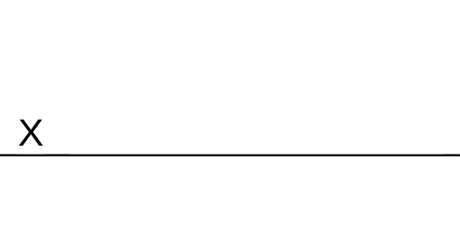
David Berman, RGD, FGDC, CPWA, ADS
David Berman Communications | www.davidberman.com | www.wcag2.com
berman@davidberman.com | @davidberman
+1-613-728-6777 | 340 Selby Avenue, Ottawa Canada K2A 3X6

Qualifications of David Berman, CPWA, WAS, CPACC, ADS and David Berman Communications
In June 2025, David Berman Communications was rated #1 nationally by the federal government’s procurement agency regarding accessibility conformance testing for websites, documents (PDF and non-PDF), mobile apps, and non-Web software.
With over 30 years of experience in design and communications, David has worked extensively in accessible Web and software interface development. David has served as Global Chair of the IAAP (the International Association of Accessibility Professionals) and an Invited Expert to the W3C (the publishers of WCAG). He has taken all available courses of the U.S. Trusted Tester program, in support of U.S. Revised Section 508. David has advised the Government of Canada and a coalition of Canada’s top accessibility organizations on the content of the Accessible Canada Act and its anticipated regulatory approach, including arguing for international harmonized adoption of EN 301 549.
David Berman is one of several hundred people in the world to hold CPWA, WAS, CPACC, and ADS certifications, the World’s only globally recognized certifications for accessibility professionals. These certifications are issued by IAAP (the International Association of Accessibility Professionals). IAAP is a division of G3ICT, for which David is an International Advisor.
David is a member of the ISO committee for accessible PDF (PDF/UA) and for plain language. Our team status as an accessibility auditor has the highest bona fides available in the World. The U.S. Department of Education’s Office of Civil Rights has reported to us that we have all the bona fides they require to deem us as acceptable for auditing Revised Section 508, Section 504, and ADA compliance.
David Berman successfully completed all certificate courses available from the Department of Homeland Security on the Revised Section 508, which are designed to qualify professionals to be able to author VPAT reports. In fact, he was asked to participate in the first cohort in order to help perfect the course material that was revised for latest Section 508 / VPAT requirements.
David was appointed by Ontario’s Minister in charge of accessibility to serve on the standards review committee for Ontario’s world-leading AODA accessibility regulations, which address WCAG 2 Level AA. He was contracted by Sir Tim Berners-Lee’s World Wide Web Foundation to audit online accessibility in over 40 countries for the annual theWebIndex.org benchmark report. In 2015, he was named an Invited Expert to W3C, the authors of WCAG. The same year he was appointed International Universal Design Champion for the Government of Ireland. In 2009, David was appointed a high-level advisor to the United Nations on how accessible Web design can help fulfill the Millennium Development Goals.
Full biography and CV: http://www.davidberman.com/about/biography

